**A**

**Project Report**

**On**

**“BEAUTY SALON MANAGEMET SYSTEM”**

**Submitted To:**

**North Maharashtra University, Jalgaon**

**In Partial Fulfillment of the Requirement of the Degree**

***TYBCA***

**Submitted By:**

**Prajakta Jawale**

**Academic Year:2022-2023**



# KCES’s Institute of Management & Research, Jalgaon

**DECLARATION**

This is certified that the Project Work entitled ***“BEAUTY SALON MANAGEMENT SYSTEM”*** submitted by me for the partial fulfillment of the TYBCA offered by the ***IMR College*** during the academic year2022-2023 is an original work carried out by me under the guidance of ***Prof. Shweta Phegade*** and this work carried has not formed for the award of any Degree, diploma or such other titles.

Date: Prajakta jawale



**CERTIFICATE**

This is to certify that__________________________________________ a student of BCA IIIrd year from KCES’S Institute of Management and Research; Jalgaon has completed the project work entitled__________________________________________________________. He/ She has submitted satisfactory project report in partial fulfillment of the requirement for the degree of BCA during academic year 2022-2023.

It is the original work and sincerely completed. I am fully satisfied with his/her performance.

**Internal Guide Coordinator HOD Director**

**External Examiner I External Examiner II**



# ACKNOWLEDGEMENT

We take this opportunity to express our deepest and special appreciation to our guide **Prof. Mrs. Shweta Phegade** for her insightful advice, motivating suggestions, invaluable guidance, help, and support in the successful completion of this project report. We express our deep gratitude to our head of the department, **Prof. Mrs. Tanuja Fegade**, and our director, **Prof. Dr. Shilpa Bendale** for their co-operation and co-ordination. We would like to convey our thanks to the teaching and non-teaching staff of our college for their help. We are also grateful to all our friends and classmates for their help and encouragement. Finally, yet, more importantly, we would like to express our deep appreciation to our parents for their perpetual support and encouragement throughout the completion of the report

***With warm regards***,

**Prajakta Jawale**

**TYBCA**

**INDEX**

|  |  |
| --- | --- |
| **Sr.** | **Title Name** |
| 1. | Abstract |
| 2. | Introduction |
| 3. | Proposed System |
| 4. | Need Of The System |
| 5. | Software & Hardware requirements |
| 6. | Diagrams |
| 7. | Database Design |
| 8. | Screen Shots |
| 9. | Conclusion |
| 10 | References |

**ABSTRACT**

Beauty salon management system is a web-based salon management application with appointment scheduling functionality. In this system user can make appointment online. In this system beauty salon owner can make their account online and give details of the services they offer and also describe the services information. User can also reschedule their appointment

User can also write and reviews about the salon or stylist. This system helps both the customer and the salon. Customer can easily find best salon in their locality and can check the review of other customer of that salon online. It helps him to take decision of taking the services of a particular salon.

**INTRODUCTION**

In present system you have to call the salon to fix an appointment. After taking an appointment you have to remember the date of the appointment. User is also not able to find the best salon in their locality. He can find out the services of any salon only after taking their services. But in proposed system you can check review online and find out who is giving best services. Use can also check that which salon gives good customer satisfaction.

In current system salon take appointment on register. They manage customer record on register. And it is very difficult to find out old appointment details in this system. Making report for the salon business is also very tiresome task. this system is prone to costly human error. Beauty parlor management system allow salon to manage stylists and services, promote sales to customers, and track customer satisfaction.

**PROPOSED SYSTEM**

Beauty parlor management system is developed to automate all the salon activity. Using this system user can manage their salon and also use this system to book appointment of his customer online. User can also check the top rated salons in his locality using this system online. User can get the address of the top rated salon in his locality by clicking on the name of the salon. Then it displays the salons that have the highest average ratings by category. Users can click on the salon’s name in order to get the address and phone number of the salon. Customer can login into the system by giving valid username and password. After login he can check his upcoming appointments. salon admin can also how many appointment they have to complete on particular date. User can also search any salon by entering its name in the search box.

**MODULES**

* **ADMIN:**
* Dashboard: In this section, admin can see all detail in brief like total number of customers, Total number of appointments, Rejected Appointment, Accepted Appointment, Total Services, Today’s sales, yesterday’s sales, Last seven days’ sales and total sales.
* Services: In this section admin can manage services of the parlor (add and update).
* Pages: In this section admin can manage about us and contact us pages.
* Appointment: In this section admin can view the detail of appointments and have the right to reject and select appointment.
* Enquiry: In this section admin can read the enquiry which is received by the users.
* Customer List: In this section admin can view customer list and assign services and make invoices of services which is taken by customer.
* Reports: In this section admin can view users’ detail and sales in particular periods
* Invoice: In this section, there is the list of total invoices which is viewed by an admin.
* Search Appointment: In this section, admin can search appointments with the help of his/her appointment number and contact number.
* Search Invoice: In this section, admin can search invoices with the help of his/her invoice number.
* Admin can also update his profile, change password and recover password.
* **USER:**
* Home Page: User can visit website.
* Services: User views the services which is offer by beauty parlor.
* About Us: User sees the details of beauty parlor.
* Contact Us: User can contact with beauty parlor.
* Book Salon: In this section, registered users can book the appointment of the parlor.
* Profile: In this section, user can view their profile.
* Setting: In this section, user can change their password.
* Booking History: In this section, User can view the status of appointment.
* Invoice History: In this section, User can view their invoices.
* Logout: User can logout from their account.

**NEED OF THE SYSTEM**

The new system is totally computerized system.

A new system provides features like time efficiency to show salon details, user profiles and whatever the customer will give the feedback to the admin. An inquiry is easily done by user in the system. It is very easy to use software.

**OBJECTIVE**

* Provide a Single environment from where an administrator can interact with the beauty shop system resources with in the beauty center network.
* Provides Info regarding the beauty parlor no of services running on the beauty center system.
* To provide an upgrade support for the beauty shop system resources.
* Provides interface to interact with the beauty shop system parameters like network settings, OS Settings, Services, and Process etc.
* Provides means of reporting the beauty parlor system setting to a person through email. There by an administrator can know the status of a systems throughout the network

**SOFTWARE & HARDWARE**

**REQUIREMENT**

A major element in building system is selection of compatible hardware & software. Hardware selection they begin with requirements analysis following by a request for proposal, evaluation & validation, post installation review.

While selecting the software, various criteria is considered such as reliability (gives consistent results), functionality (function to standards), capacity (satisfies volume requirements), flexibility (adapts to changing needs), usability (user friendly), security (to prevent unauthorized access), performance (capacity to deliver as expected), serviceability (good documentation), minimal cost (affordable for intended application).

## **SOFTWARE REQUIREMENTS**

Windows, Xamp.

My SQL Server.

## **HARDWARE REQUIREMENT**

Processor – 2.5 GHZ

Ram – 2 GB MB.

Hard Disk-50 GB Monitor, Mouse, Keyboard

## **FRONT END: HTML, CSS, JAVASCRIPT**

1. HTML: HTML is used to create and save web document.
2. CSS: (Cascading Style Sheets) Create attractive Layout
3. JavaScript: it is a programming language, commonly use with web browsers.

## **BACK END: PHP, MYSQL**

1. PHP: Hypertext Preprocessor (PHP) is a technology that allows software developers to create dynamically generated web pages, in HTML, XML, or other document types, as per client request. PHP is open-source software.
2. MySQL: MySQL is a database, widely used for accessing querying, updating, and managing data in databases.

# DIAGRAMS

**DATA FLOW DIAGRAM (DFDS):**

A Data Flow Diagram (DFD) is a graphical representation of the "flow" of data through an Information System. A data flow diagram can also be used for the visualization of Data Processing. It is common practice for a designer to draw a context-level DFD first which shows the interaction between the system and outside entities. This context-level DFD is then "exploded" to show more detail of the system being modeled.

**Level -0 DFD**



valid

Enter User name

ADMIN

MANAGE SALON & USER

And Password

DB

Has to

register

user

enquiry

enquirv

booking

contact

Under goes

Under goes

Under goes

admin

service

provide

invoice

**USE CASE DIAGRAM**

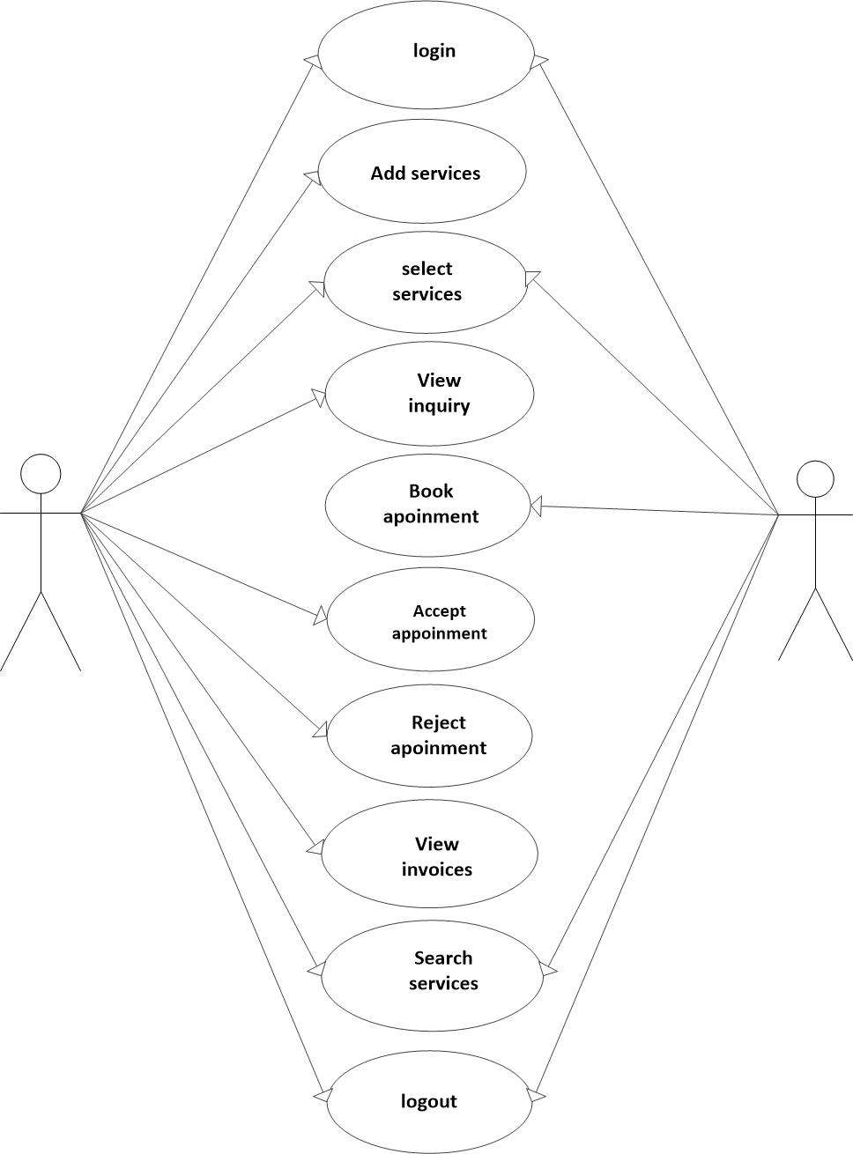

**user**

**Admin**

**ACTIVITY DIAGRAM**

Sign in

Log in

No

Yes valid user

-------------------------------------------------------------------

contact

Passwrd change

Search service

Book service

-------------------------------------------------------------------

**DATABASE DESIGN**

**Admin:**

|  |  |
| --- | --- |
| Field | Type |
| Id | int (10) |
| adminName | char (50) |
| userName | char (50) |
| mobileNumber | bigint (10) |
| Email | varchar (200) |
| Password | varchar (200) |
| adminRegDate | timestamp |

**tblBook:**

|  |  |
| --- | --- |
| Field | Type |
| Id | Int (10) |
| userId | Int (10) |
| aptNumber | Int (10) |
| aptDate | Date |
| aptTime | Time |
| Message | Mediumtext |
| bookingDate | timestamp |
| Remark | varchar (250) |
| Status | varchar (250) |
| remarkDate | timestamp |

**tblContact:**

|  |  |
| --- | --- |
| Field | Type |
| Id | Int (10) |
| firstName | varchar (200) |
| lastName | varchar (200) |
| Phone | Bigint (10) |
| Email | varchar (200) |
| Message | Mediumtext |
| inquiryDate | timestamp |
| isRead | varchar (5) |

**tbleInvoice:**

|  |  |
| --- | --- |
| Field | Type |
| Id | Int (11) |
| userId | Int (11) |
| serviceId | Int (11) |
| billingId | Int (11) |
| postingDate | timestamp |

**tblPage:**

|  |  |
| --- | --- |
| Field | Type |
| Id | Int (10) |
| pageType | varchar (200) |
| pageTitle | Mediumtext |
| pageDiscription | Mediumtext |
| Email | varchar (200) |
| mobileNumber | Bigint (10) |
| updationDate | date |
| Timing | varchar (200) |

**tblServices:**

|  |  |
| --- | --- |
| Field | Type |
| Id | Int (10) |
| serviceName | varchar (200) |
| serviceDescription | Mediumtext |
| Cost | Int (10) |
| Image | varchar (200) |
| creationDate | timestamp |

**tblUser:**

|  |  |
| --- | --- |
| Field | Type |
| Id | Int (10) |
| firstName | varchar (120) |
| lastName | varchar (250) |
| mobileNumber | Bigint (10) |
| Email | varchar (120) |
| Password | varchar (120) |
| regDate | timestamp |

**SCREEN SHOTS**

**DASHBOARD :**

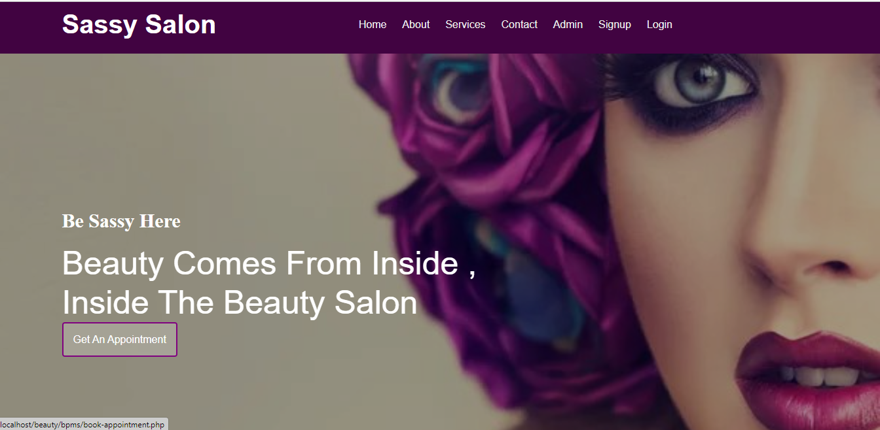

**Admin login:**

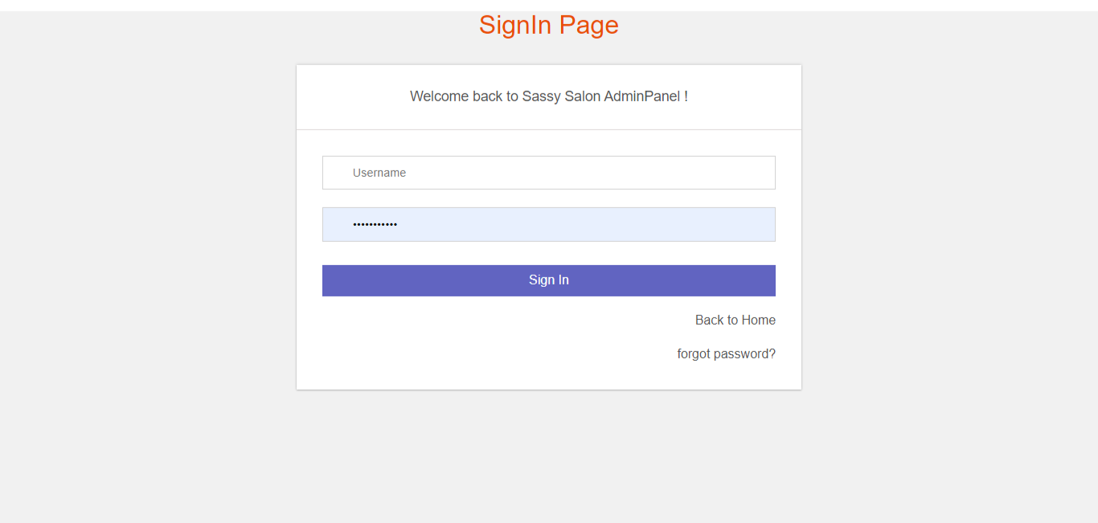

**Admin dashboard:**

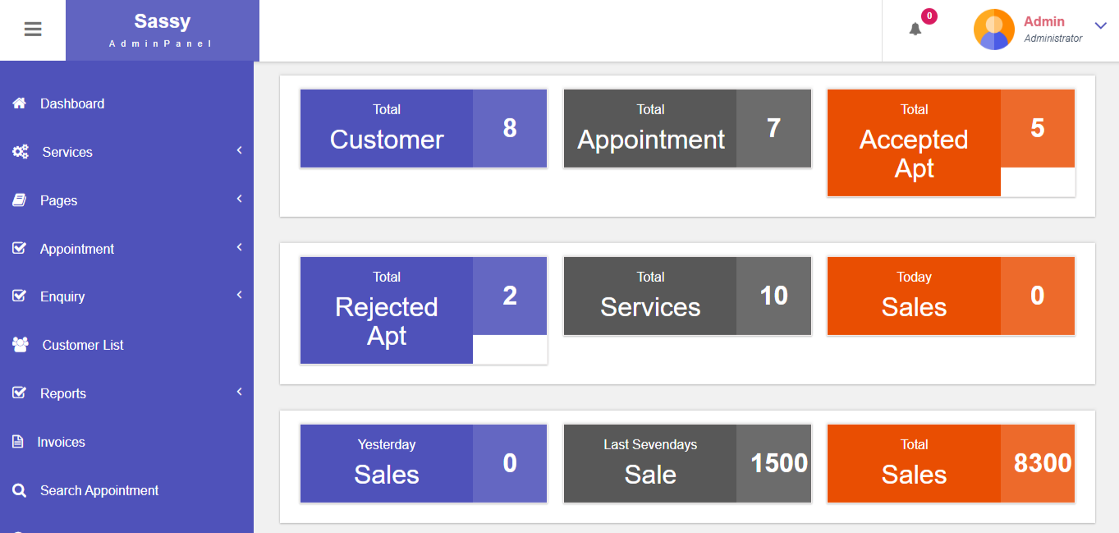

**Add service :**

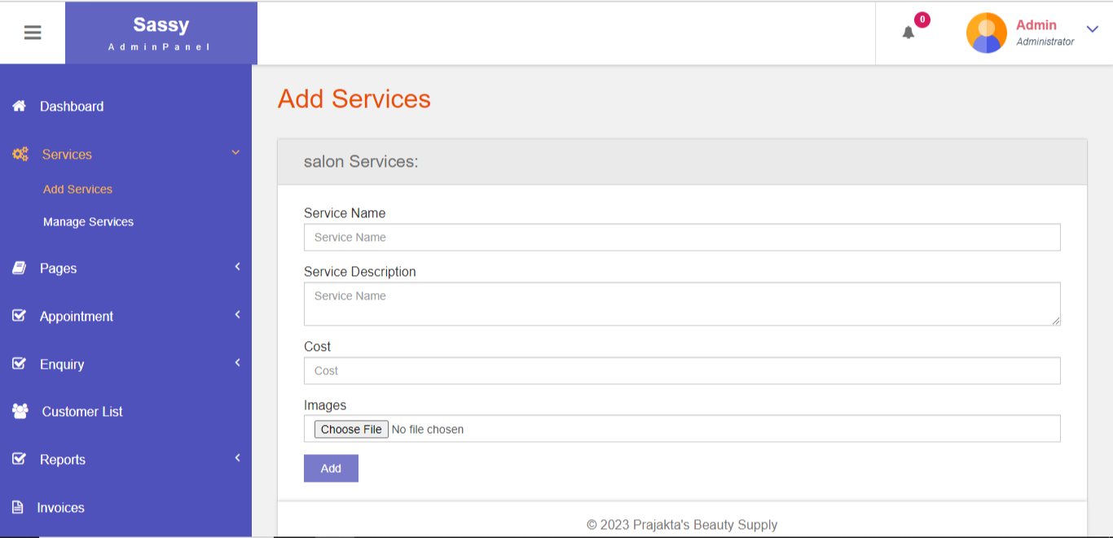

**Manage service:**

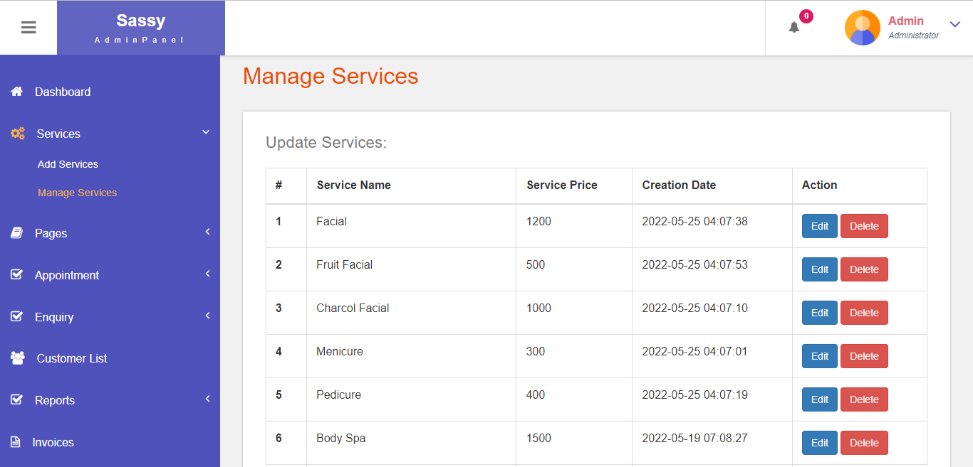

**About us:**

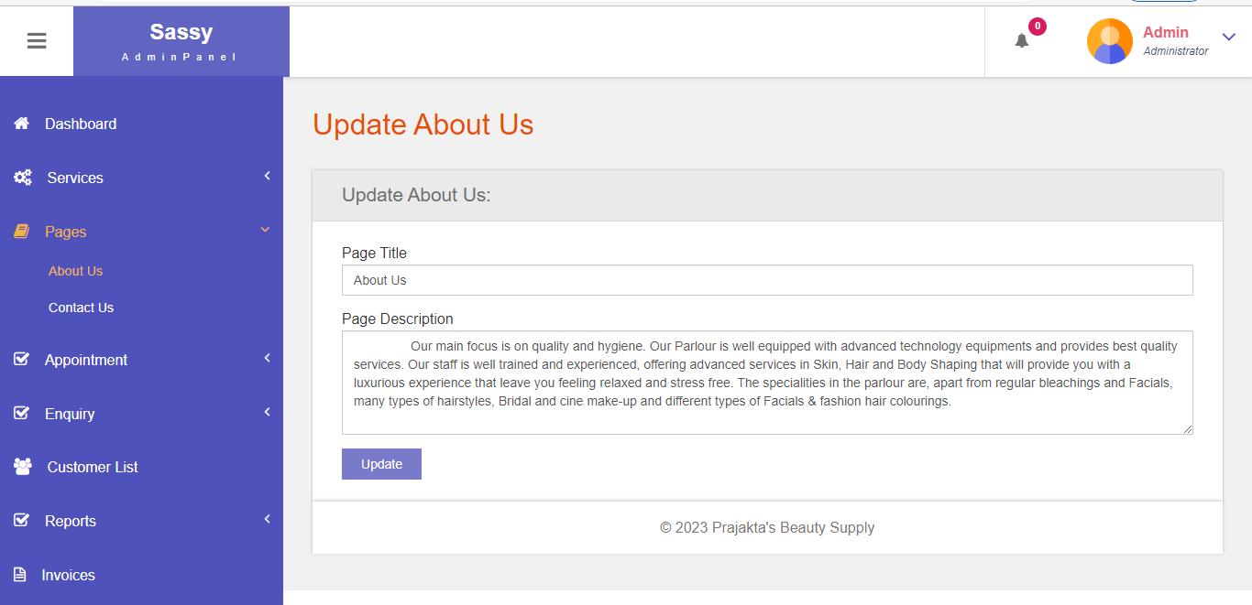

**Contact us:**

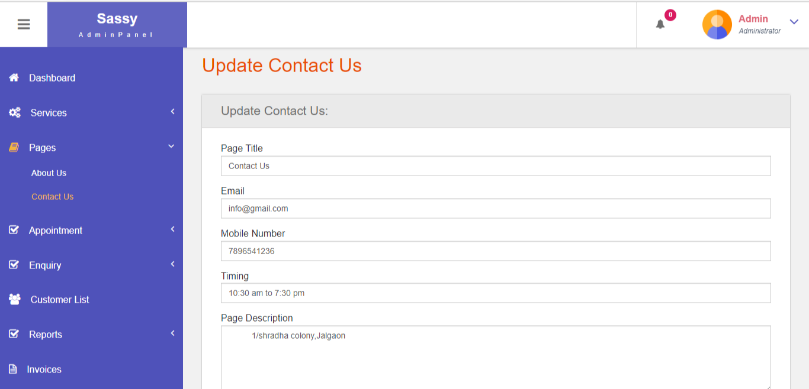

**All appoinments:**

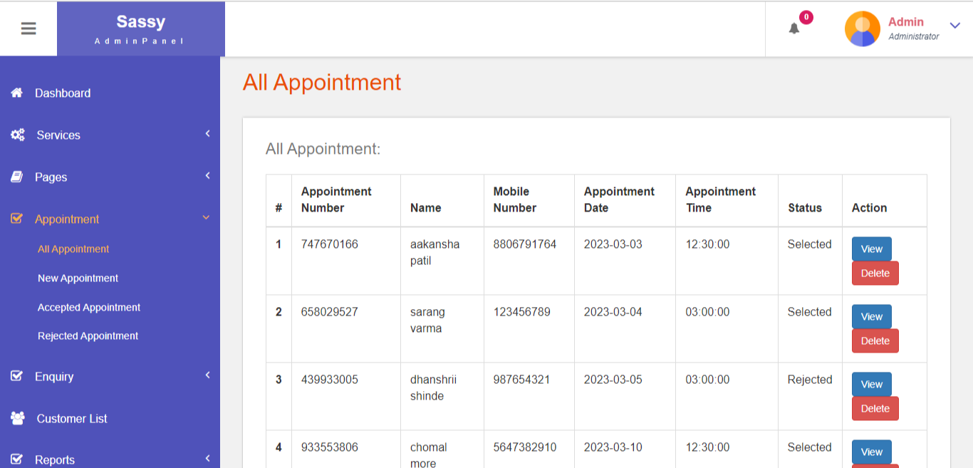

**Accepted appoinments:**

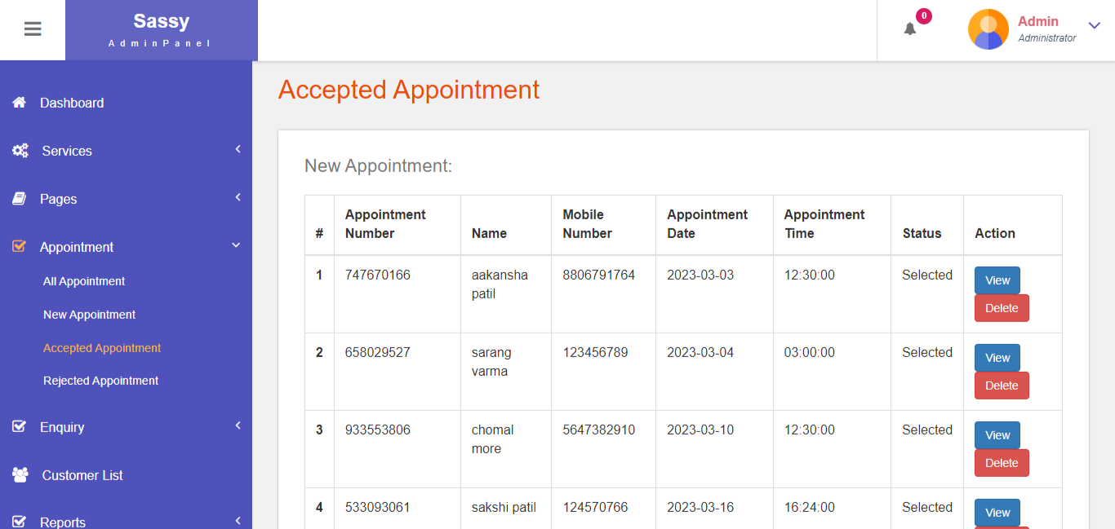

**Rejected appoinments:**

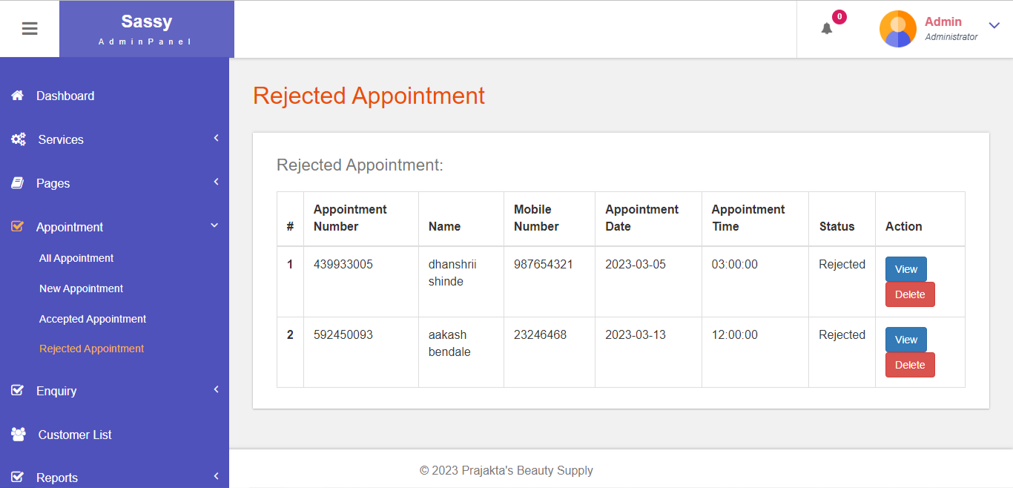

**Read inquiry:**

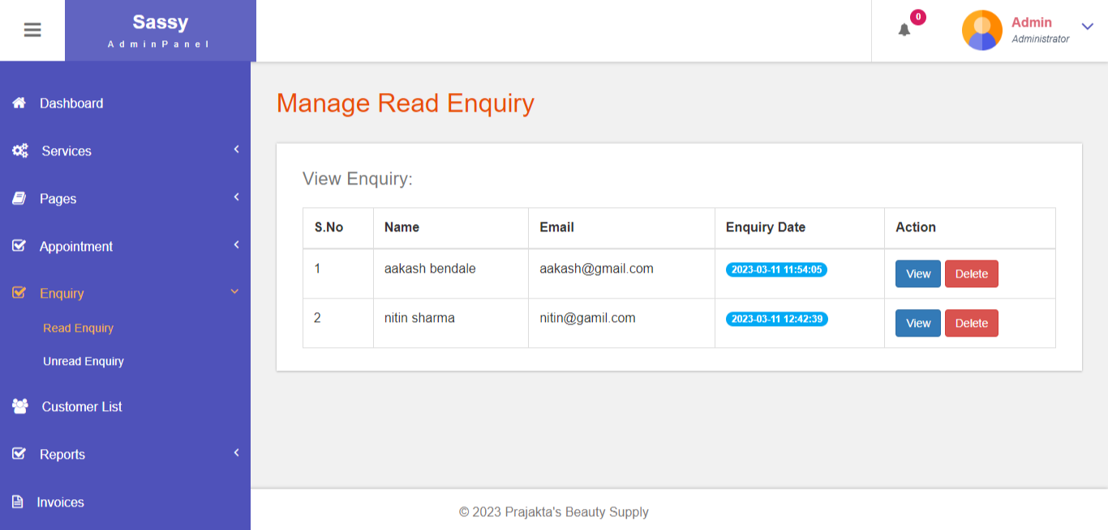

**Customer list:**

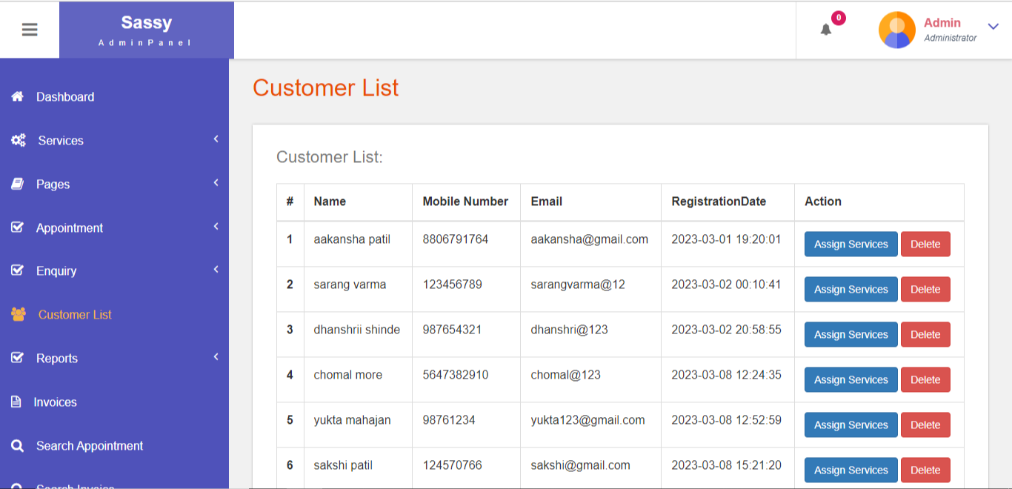

**Date reports:**

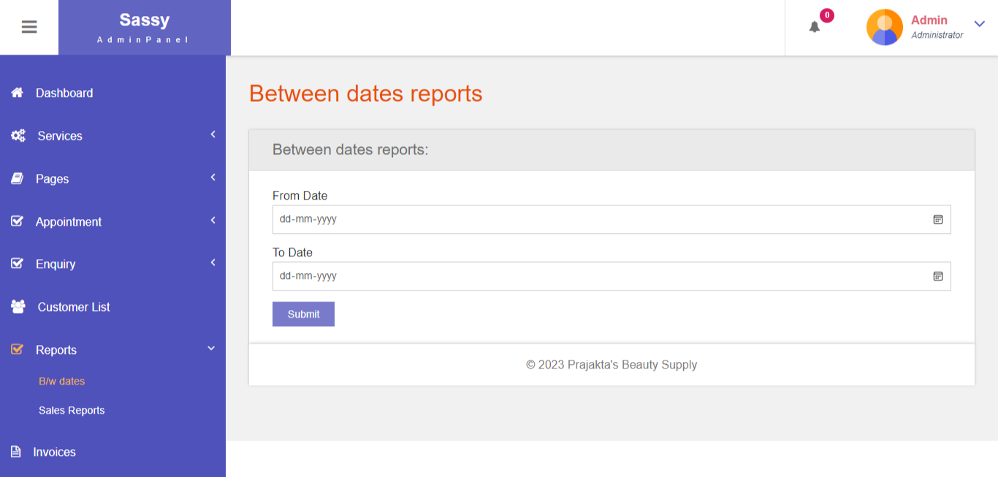

**Sales report:**

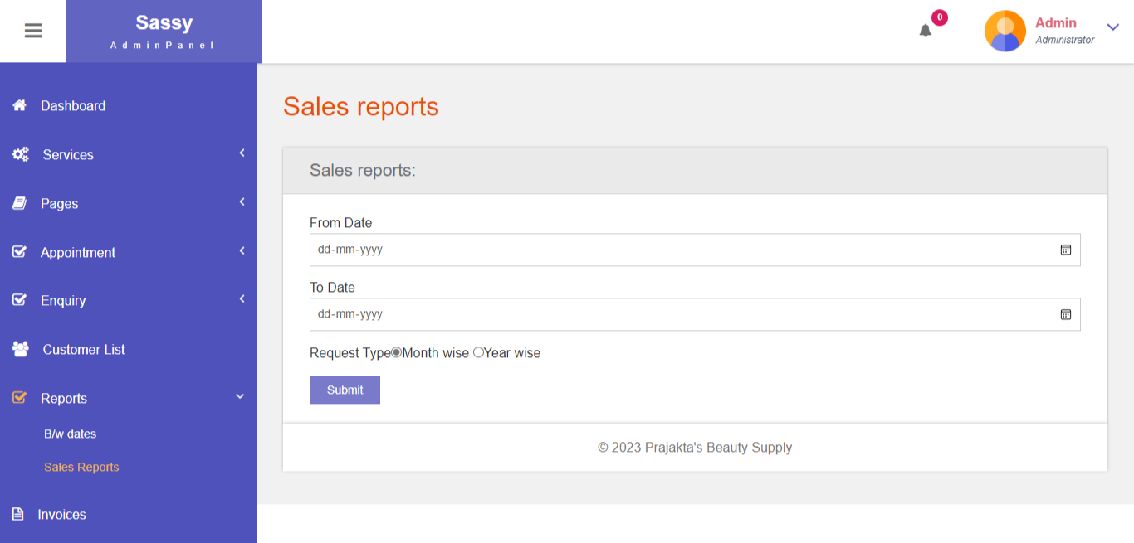

**Invoice list:**

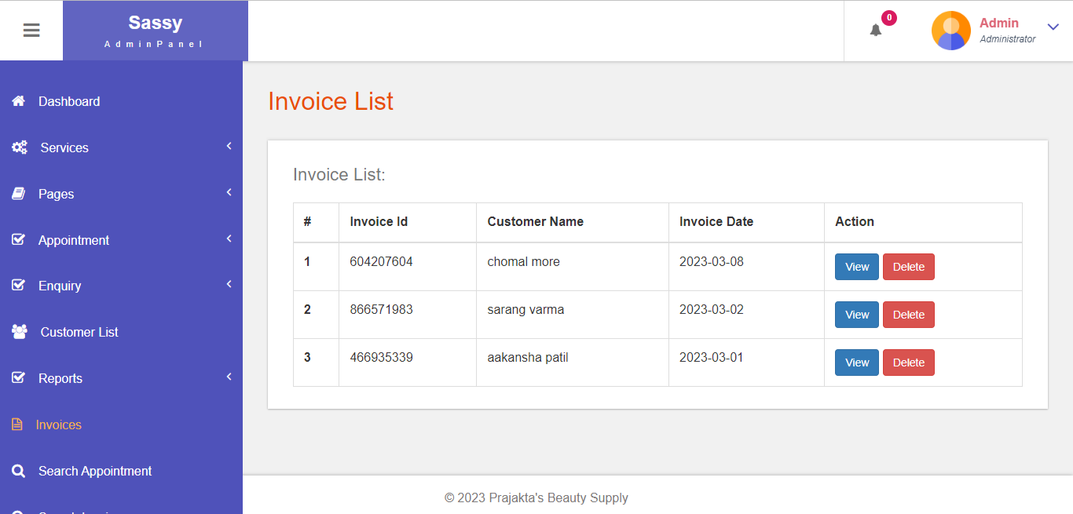

**Search appointment:**

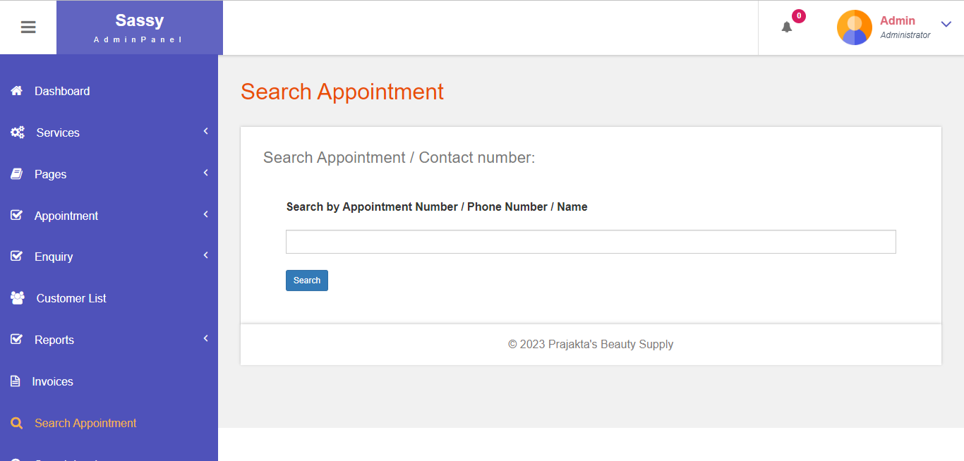

**Search invoice:**

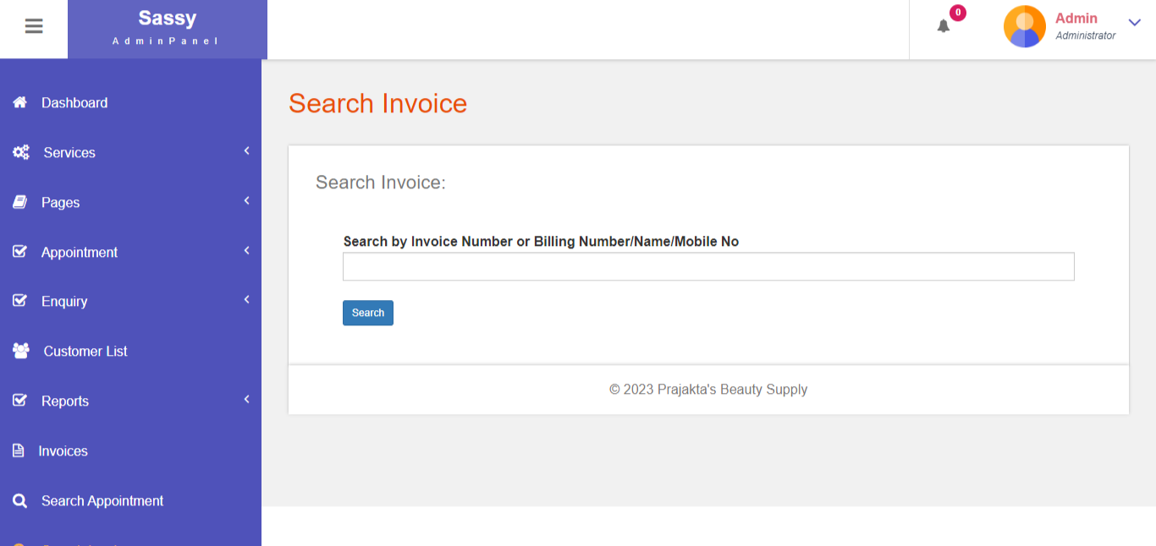

**CONCLUSION**

Salons are a business that thrives on the segment of customers who value pampering and attention to detail. But as a salon owner, it can be hard to keep up with tracking and managing appointments.

Besides, many salons do not have the time or resources to invest in an expensive salon appointment system that might not suit their needs. Alternatively, they need something flexible and easy-to-use that will help them automate their processes and manage all aspects of their business.

That’s where a mobile salon appointment booking solution comes in handy. Salons or Beauty parlor management software make the entire business more organized and efficient. The software helps manage a hair salon business quite rigorously: tracking inventory, managing client data, managing the staff performance, hours, and schedules, as well as planning marketing campaigns.

**REFERENCES**

## **BOOKS:-**

* PHP Solutions: Dynamic Web Design
* Beginning PHP and MySQL
* Learning PHP, MySQL, and JavaScript
* PHP Object-Oriented Solutions
* PHP And MySQL Web Development
* MY SQL 2005

## **WEBSITE:-**

* [www.phpmyadmin.net/www.fricard.com](http://www.phpmyadmin.net/www.fricard.com)
* [www.w3schools.com/php/default.asp](http://www.w3schools.com/php/default.asp)